**Project SIRSIP**

***Configuration***

**1.0 Master Data**

**1.1 Doctor**

**1.1.1 Data Pribadi Dokter**

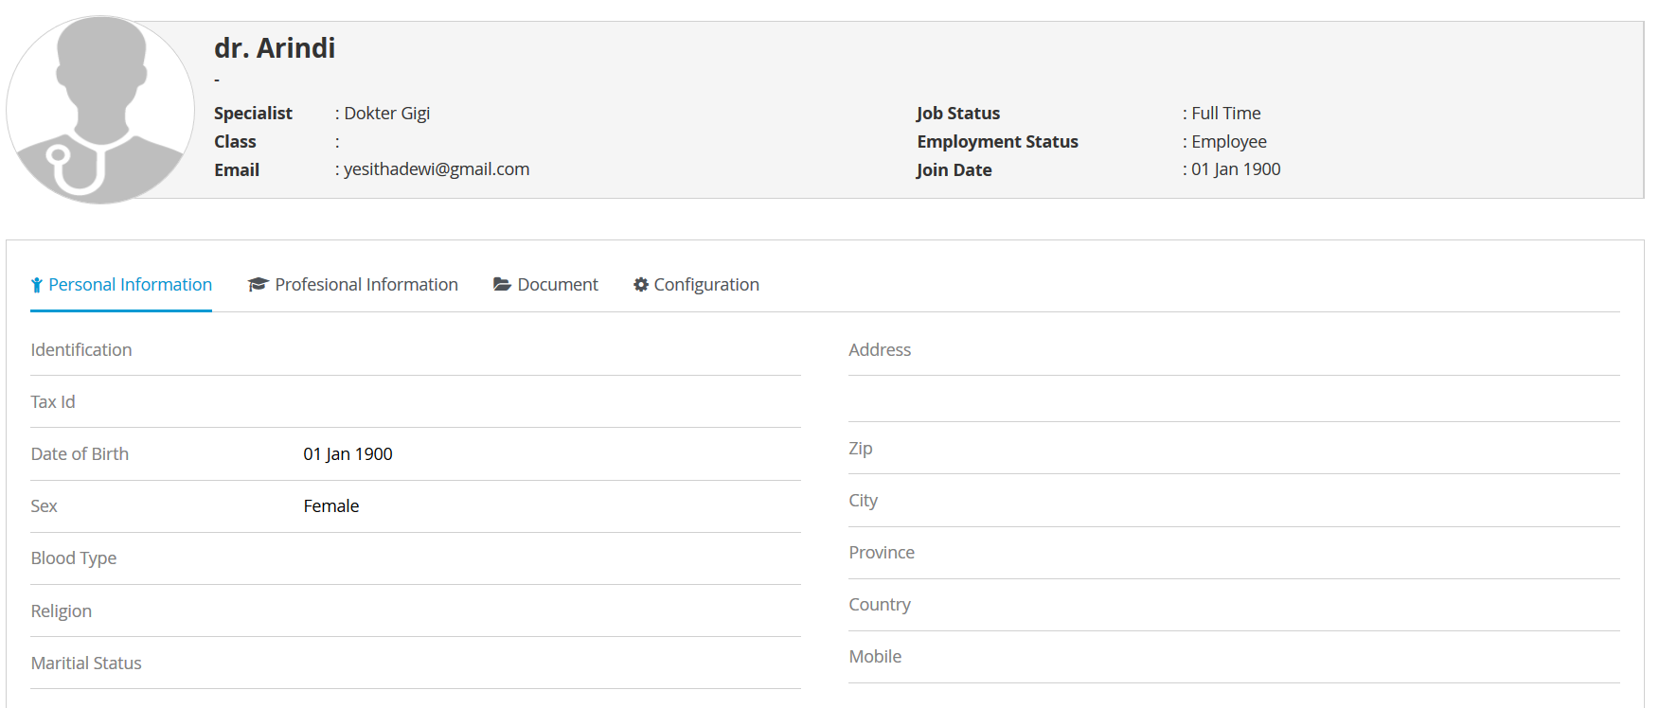

**Data Profesional Information**

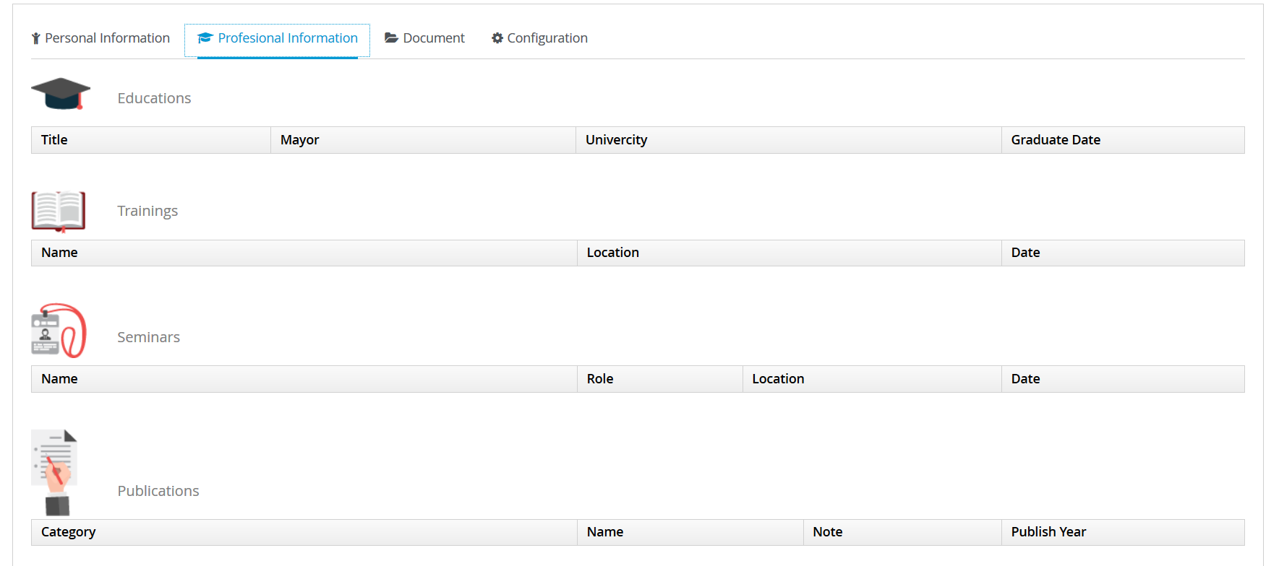

**Document**

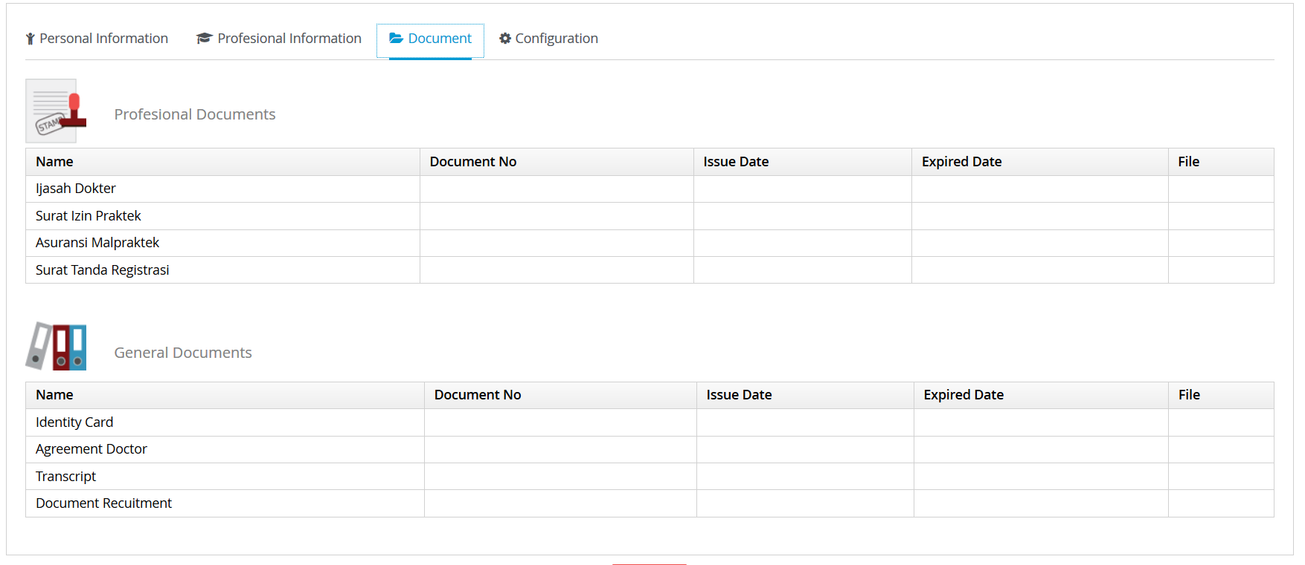

**Configuration**

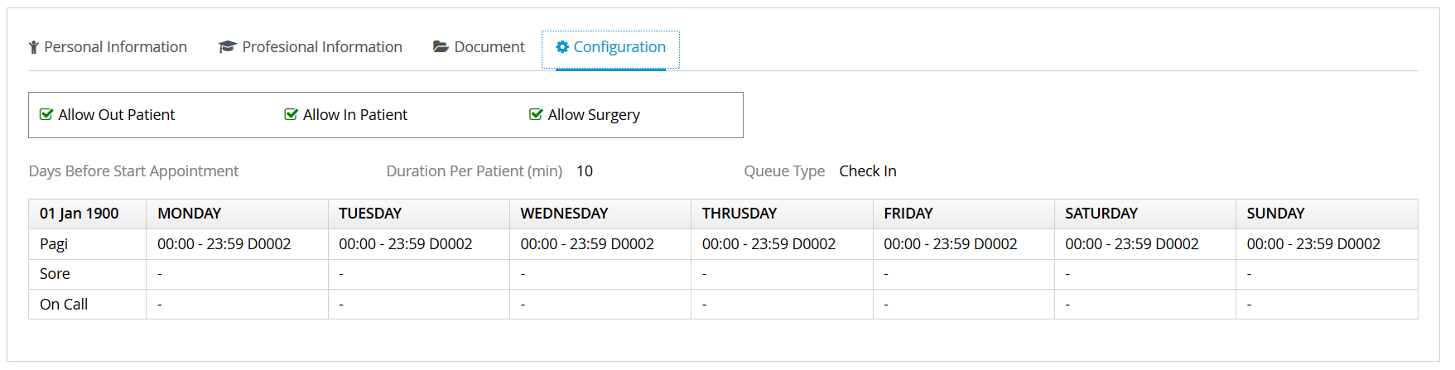

**1.1.2 Doctor External**

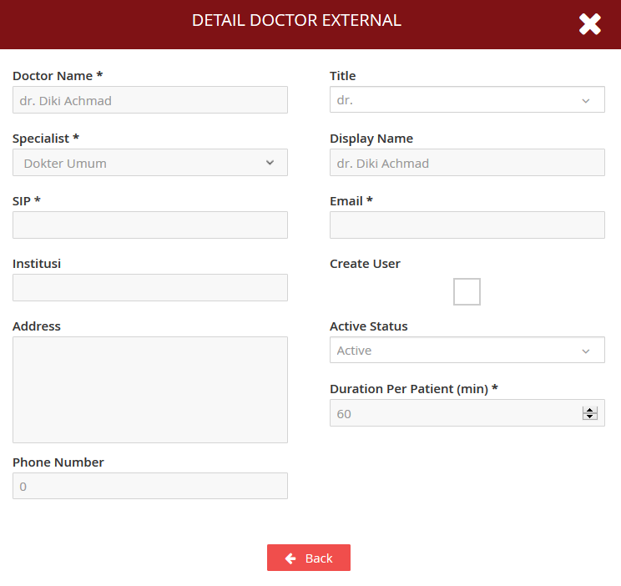

**1.1.3 Non Doctor Operator**

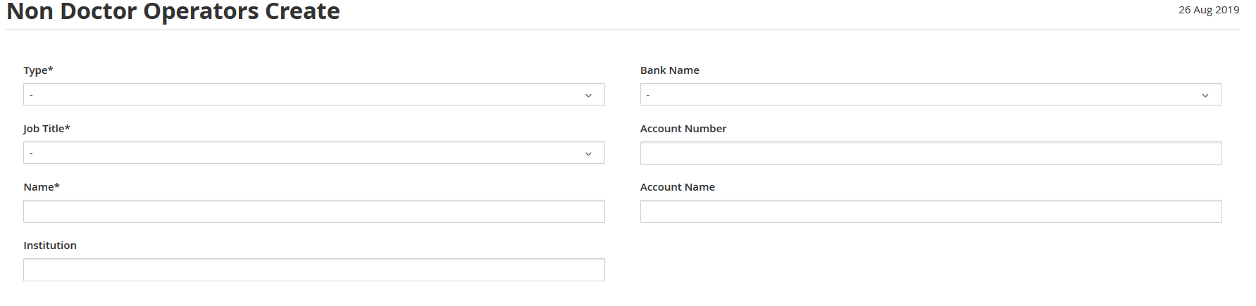

**1.1.4 Patient**

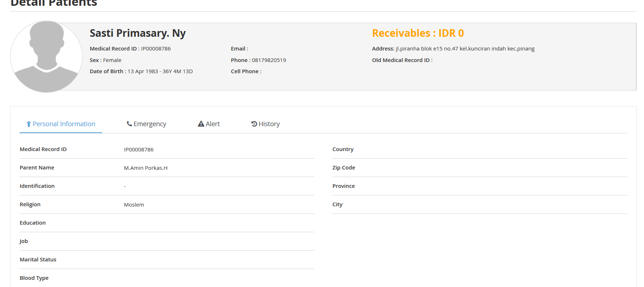

**Emergency**

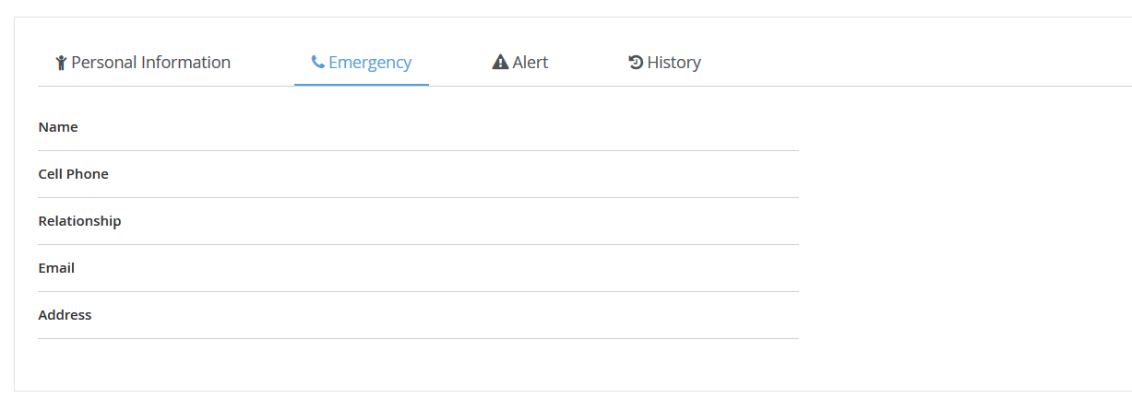

**Alert**

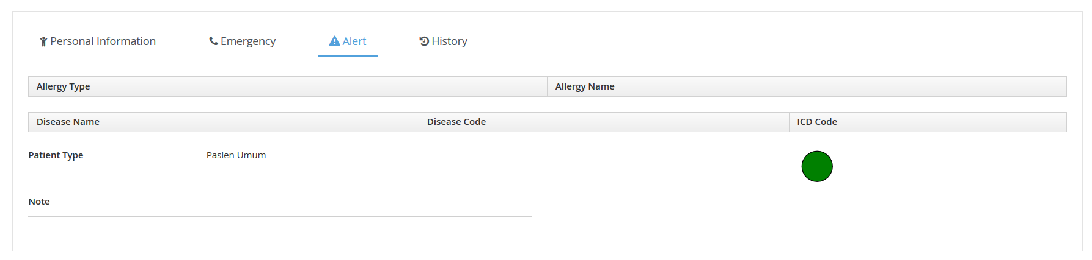

**History**

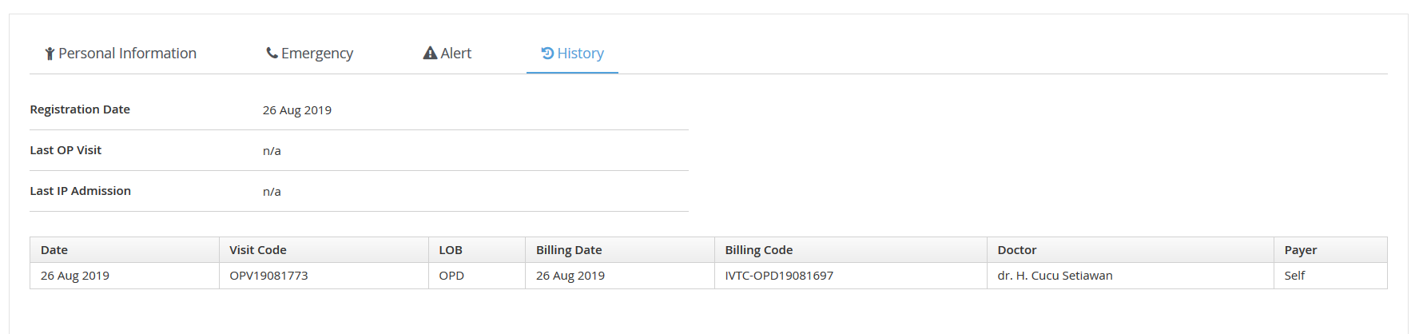

**1.1.5 Room**

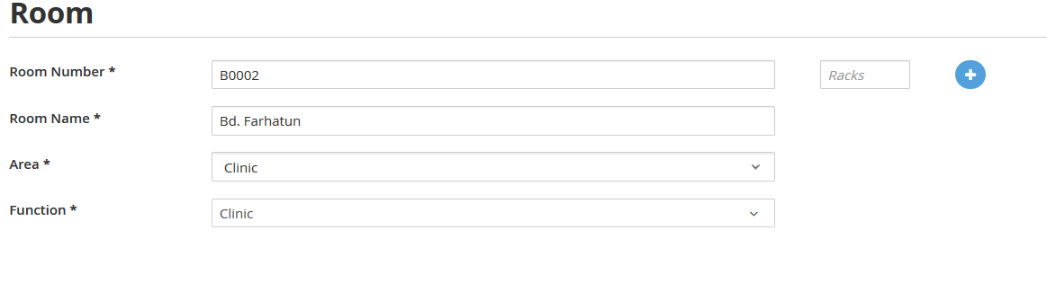

**1.1.6 Company**

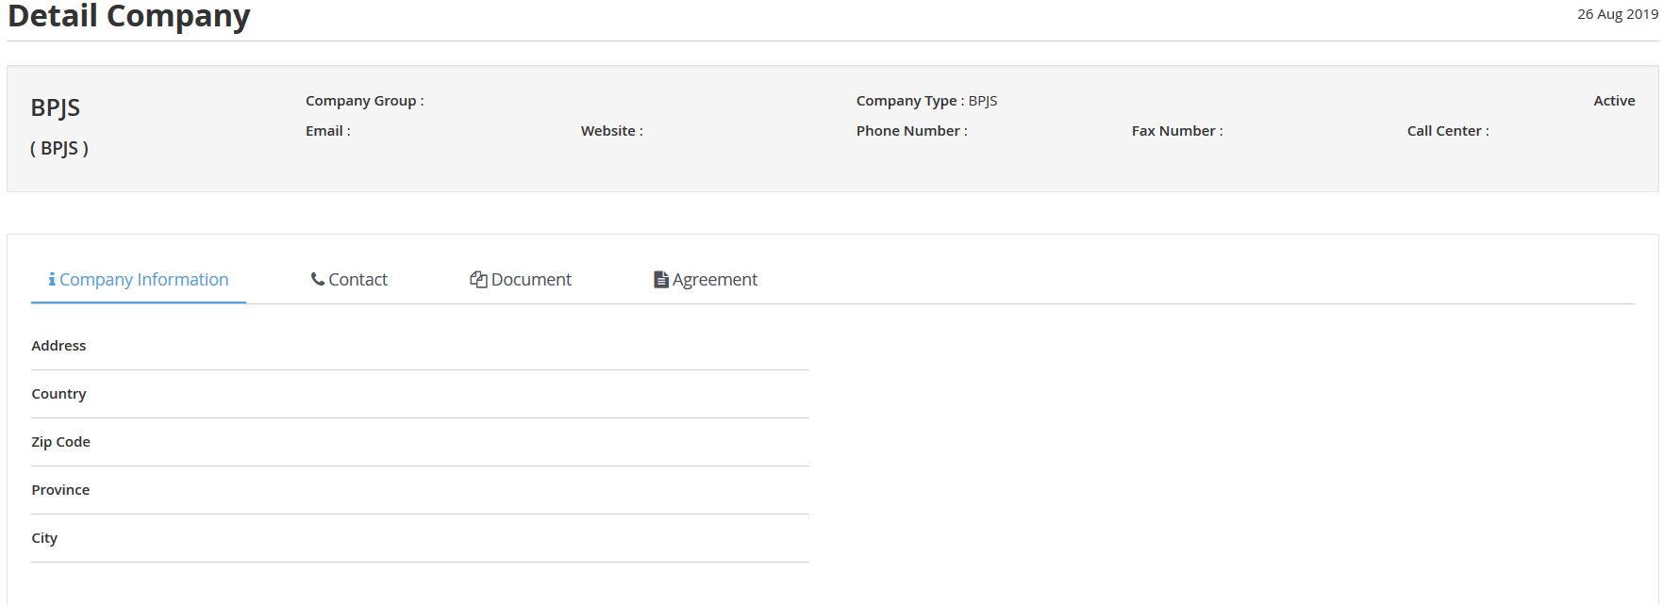

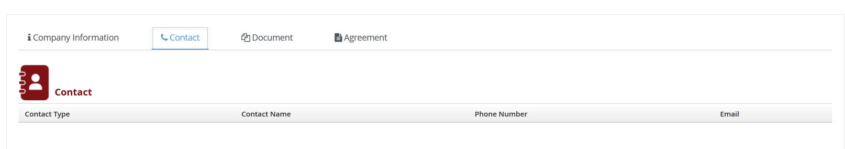

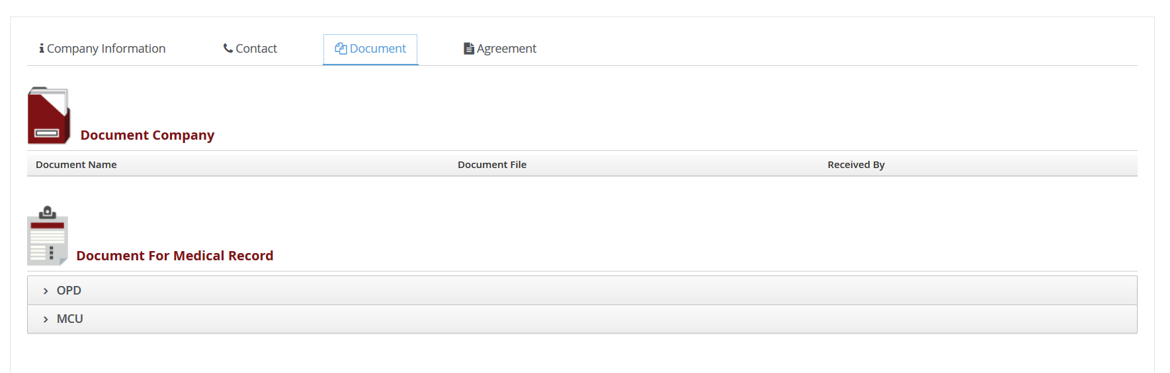

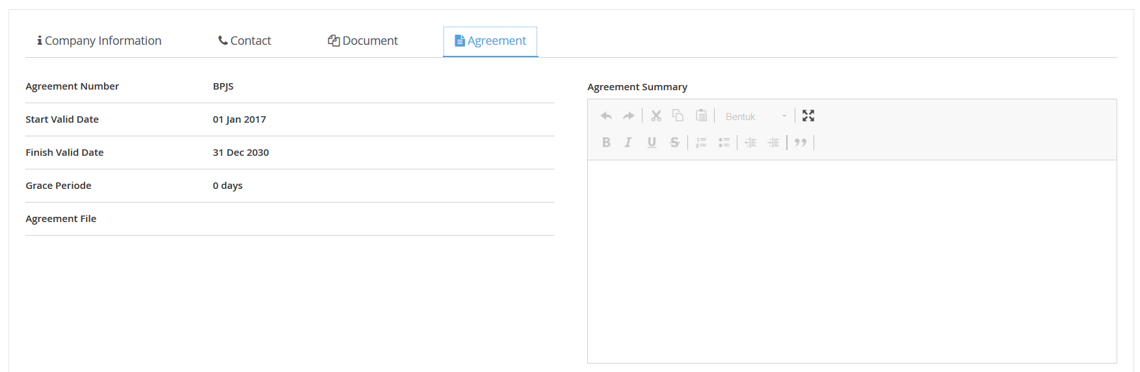

**1.1.7 Schemas**

